MACH4METAL

metalworking machinery
Transito 21
6909 DA BABBERICH Netherlands
Tel. +31 (0)316-247123
info@mach4metal.com
www.mach4metal.com
Bank No : 66.52.13.883
IBAN : NL33 INGB 0665 2138 83
BIC : INGBNL2A

EBU Excentric press 16.000 Kg

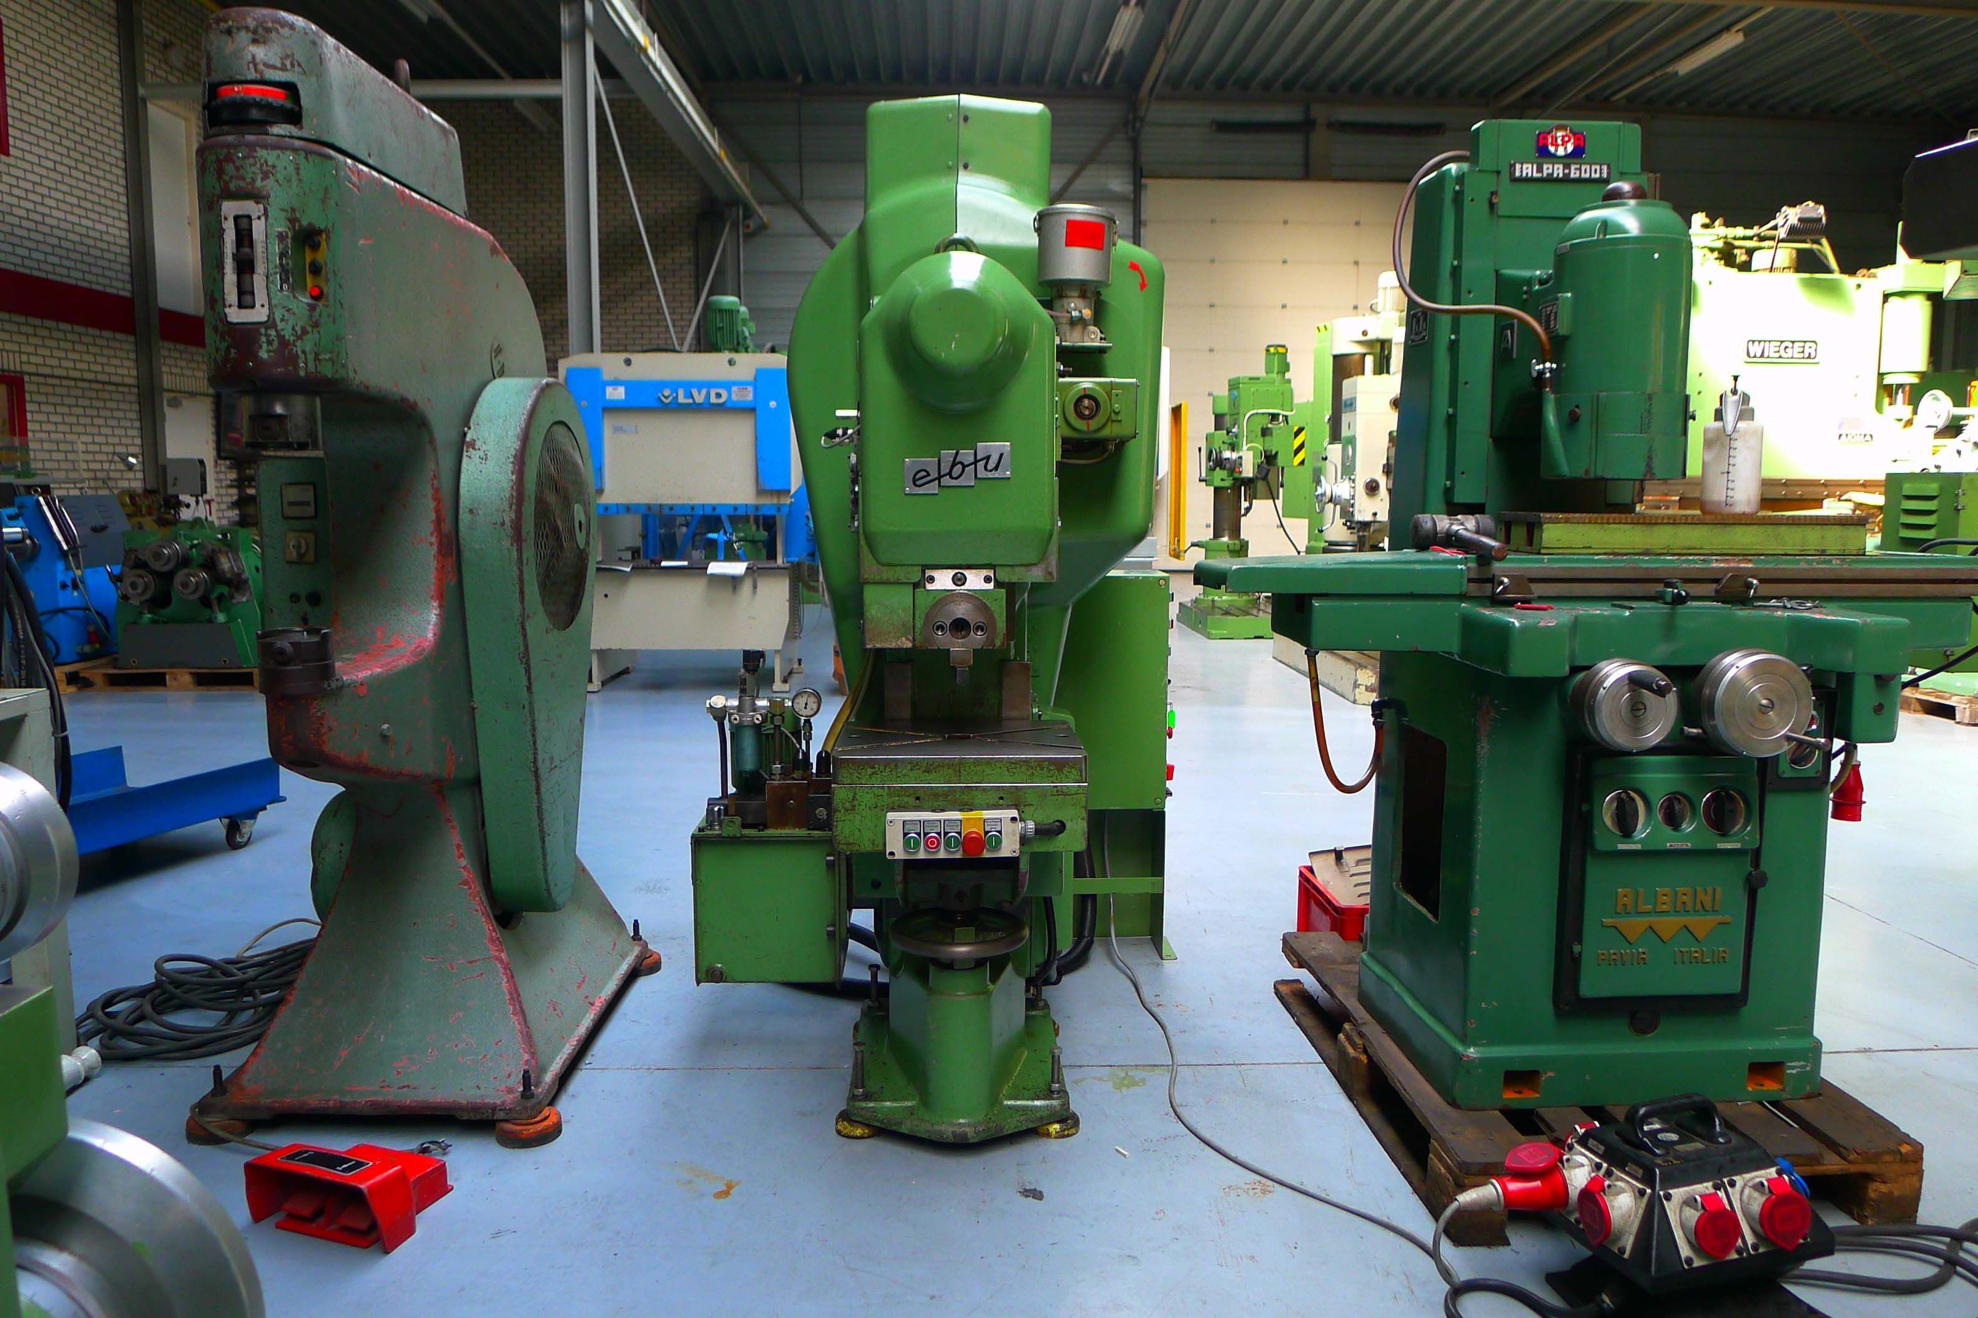
- Make. : Ebu (Burkhardt GmbH)
- Typ : H 16
- YOP : 1992
- Serial : P-5355787

- Pers druk. 16 t
- Aantal slagen p/min. 40 - 160

- Slag verselling. 4 - 70
- Ram verstelling. 80 mm
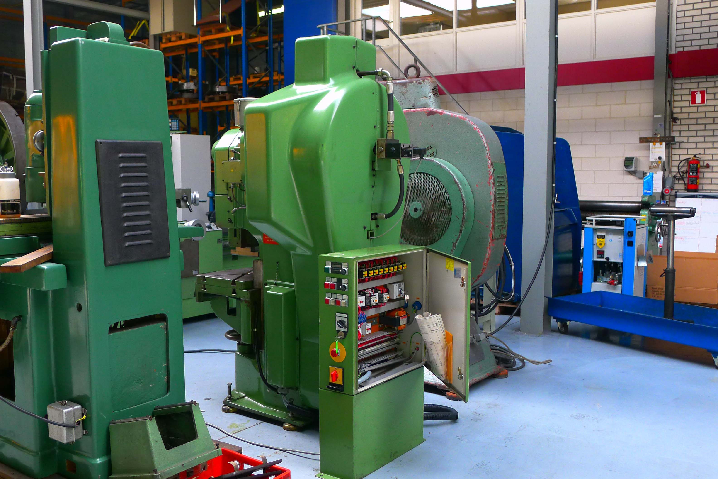
- Uitlading. 210

- Tafel afm. 430 x 390
- Doorval gat tafel. 60

- Inbouw hoogte: 185 mm

- Inbouw hoogte: 195 mm ( verst. Tafel)

- Afm. + Gewicht. 1,10 x 1,0 x 2,10 / 1,4 t.
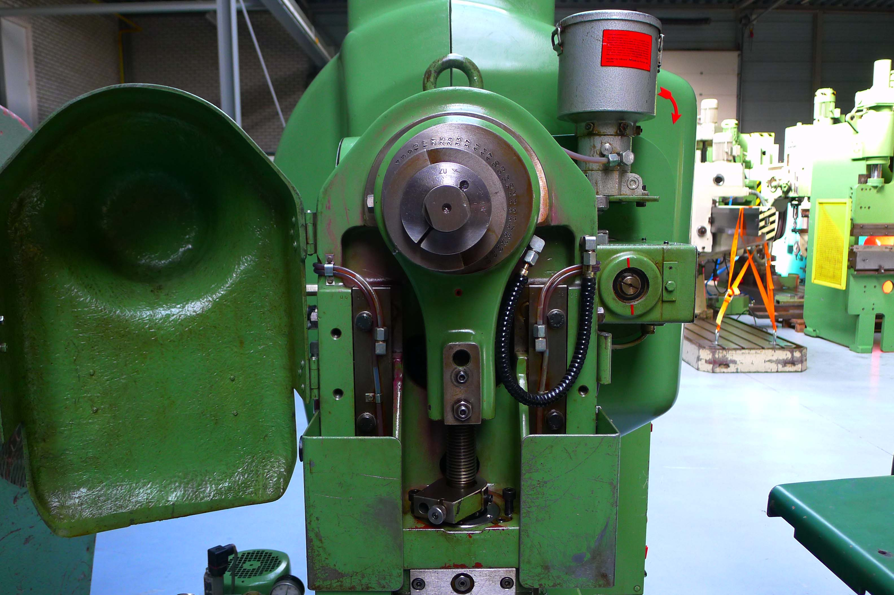
- Centrale smering
- Lucht koppeling

- Sep. Schakel / bedieningskast

- Nieuw. Euro 40.000,-

Please Note: The above information has been obtained to the best of our ability and belief from, and from the manufacturers where possible. It is given in good faith, but its accuracy can not be guaranteed. Accordingly, it will not form a representation or constitute contractual terms. We advise you to check any vital details!

